Heddon on the Wall Parish Council

The minutes of the annual Heddon-on-the-Wall Parish Council meeting,
held on 11th May 2016 at 6.00 p.m. in Heddon Library

- APPOINTMENT OF THE CHAIRMAN OF THE PARISH COUNCIL
Mrs Gardner-Medwin was proposed, seconded and appointed to the office of Chairman.
- APPOINTMENT OF THE DEPUTY CHAIRMAN OF THE PARISH COUNCIL
Mr Adams was proposed, seconded and appointed to the office of Deputy Chairman.
- DECLARATIONS OF ACCEPTANCE OF OFFICE
Declarations of acceptance of office will be signed later in the presence of the clerk.
- PRESENT & APOLOGIES FOR ABSENCE
Present: Mrs Gardner-Medwin (chair), Mr Armstrong, Mr Adams, Mr Iley, Mrs Thompson, Mr Young, Mr Tailford, Mrs Cruickshank, Councillor Jackson, clerk (Mrs Pringle).
- APPOINTMENT OF COMMITTEE MEMBERS
- Planning Committee: Mr Armstrong, Mr Iley, Mr Adams, Mrs Gardner-Medwin.
- Finance Committee: Mr Armstrong, Mr Iley, Mr Young, Mrs Gardner-Medwin.
6) MINUTES OF THE MEETING HELD ON 13th APRIL
The minutes were approved and signed by the Chairman.
b) EXCLUSION OF PRESS AND PUBLIC - COUNCIL MEMBERS ARE INVITED TO CONSIDER PASSING THE FOLLOWING RESOLUTION:
‘That under Section 100A (4) of the Local Government act 1972, the press and public be excluded from the meeting during the disclosure of the following items on the agenda as they involve the likely disclosure of exempt information as defined in Part 1 of schedule 12A in the 1972 Act as indicated below.’
Issues concerning: Personnel matters
Kim Pearson was confirmed in the role of Assets Officer starting on 16th March 2016
The Parish Council agreed to give David Greensitt an ex gratia payment of £750, in gratitude for the work he had done for the Library and Business Centre and the community of Heddon.

7) MATTERS ARISING FROM THE MINUTES
Owner | Action | Status
L Pringle | Formal complaint to NCC re. Unauthorised use of agricultural buildings. | Ongoing
L Pringle | Prepare audit paperwork for next meeting | Completed
R Young | Repair surface under swings in Welfare Field | Ongoing
L Pringle | Order Good Councillors guide | Completed
I Armstrong | Organise Library Business Centre Committee | Deferred July
I Armstrong | To ring the owners regarding clarification Dingle Dell Plans | Completed
A Gardner Medwin/L Pringle | To write Knott Memorial Hall letter | Completed
R Young | Check Memorial Park shelter repair. | Completed
L Pringle | Contact small allotment holders | Completed
L Pringle | Speak to Mr.Haddon | Ongoing
L Pringle | Arrange fence repair on allotment 8. | Ongoing
L Pringle | Prepare schools objection | Completed
A Garner Medwin  I Armstrong | Prepare report for residents meeting. | Completed
L Pringle | Prepare advert for residents meeting. | Completed
L Pringle | Update publication schedule and transparency issues, councillors responsibilities and land/buildings on website | Ongoing

8) ACCOUNTS
Spending was approved for the bunting for the Queens Birthday Celebration.
Accounts paid and received were approved and seconded

9) APPROVAL OF THE ANNUAL STATEMENT OF ACCOUNTS & ANNUAL
GOVERNANCE STATEMENT (2014-2015)
The Parish Council approved the Annual statement of Account & Annual Governance statement for 2015-2016 and the chair signed the Annual Return which will now be sent to the External Auditors.
10) CHANGE ON DATE JUNE MEETING
The June meeting will take place on 15th June at 19.00 in the library, advance apologies were accepted from Mr Iley and Mr Adams.

11) REPAIRS AT ALLOTMENTS
It was agreed to go ahead with the essential fencing repairs at the allotments, costing approx. £525.
12) PLANNING
- Rudchester Farm Cottage Rudchester Northumberland NE15 0JA Ref. No: 16/01300/LBC Listed Building Consent: Refurbishment of farm cottage and conversion of loft to form two bedrooms and bathroom with dormer windows. Dormer windows to front and rear elevations. Two conservation grade roof windows. No objections
- The Swan Inn The Towne Gate Heddon-On-The-Wall NE15 0DR Ref. No: 16/01294/ADE Advertisement consent for 1no externally illuminated hanging sign, 4no externally illuminated sets of letters & 2no lanterns. No objections
- Bellamor Holmeside Heddon On The Wall Newcastle Upon Tyne Northumberland NE15 0HF Ref. No: 16/01391/VARYCO Variation of Condition 2 relating to planning application 16/00114/FUL - (Change of use of residential garden land to agricultural, change of use of agricultural land to residential garden as approved under 15/01007/FUL, construction of replacement building for residential use in lieu of replacement building for residential use approved under 15/01007/FUL, construction of leisure building as approved under 15/01007/FUL, construction of outbuilding (garages) in lieu of office/workshop building approved under 15/01007/FUL, conversion of existing barn within existing residential curtilage to form a separate residential dwelling and relocation of type 7 access and vehicular track approved under 15/01007/FUL). No objections
- Building East Of Former Cricket Pavilion Close House Mansion Close House Estate Heddon-On-The-Wall Northumberland Ref. No: 16/01372/FUL Extension to provide additional storage space for existing Green Keepers building. No objections
- 76 Trajan Walk Heddon On The Wall Newcastle Upon Tyne Northumberland NE15 0BL Ref. No: 16/01410/FUL Proposed single storey extension to rear creating new kitchen/bedroom with en-suite and new living room. No objections.
The following planning applications have now been granted:
- 16/00684/FUL : 12 Campus Martius
Single storey rear extension.

13) CORRESPONDENCE
NCC – email – Litter campaign, it was decided to support this campaign and order posters.
Newcastle Airport - Mr Iley stated that due to the number of complaints regarding airport noise, representatives from the airport will be visiting the next council meeting to speak to residents.

There being no further business, the meeting closed at 6.45pm.

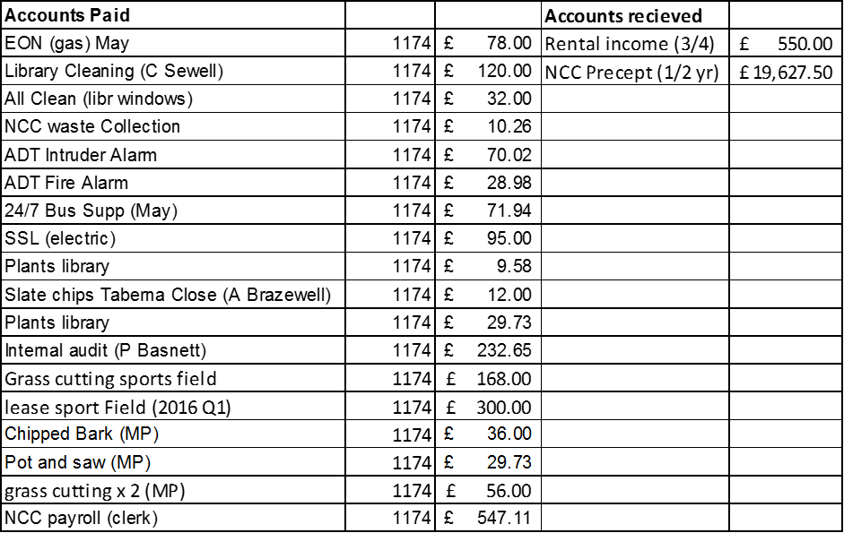

Owner | Action | Status
L Pringle | Formal complaint to NCC re. Unauthorised use of agricultural buildings.
L Pringle | Add Airport to June agenda
R Young | Repair surface under swings in Welfare Field
L Pringle | Renew bark under swings Welfare Field
L Pringle | Speak to Mr.Haddon
L Pringle | Arrange fence repair on allotment 8.
L Pringle | Arrange paperwork for new Assets officer
L Pringle | Report Chevron sign Rudchester crossroads
L Pringle | Price replacement sign for Welfare Field

